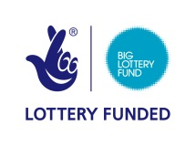
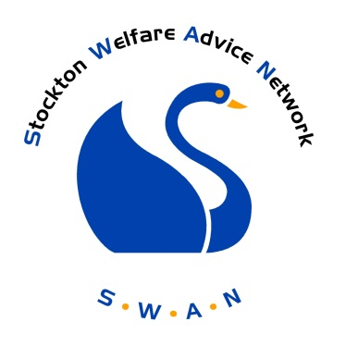

Stockton Welfare Advice Network
Benefits of
FULL MEMBERSHIP

Background

The SWAN was initiated on 1st October 2013 by nine organisations with experience of advice provision and an expertise of the issues and problems faced by the residents of Stockton Borough.

The project is funded through the Advice Service Transition Fund, administered through the Big Lottery Fund.

The overall aim of the project is to enable residents to easily and quickly access the right advice at the right time. This will be achieved by:

- The establishment of a Network, a group of advice agencies coming together through meetings and electronic communication through the SWAN website to share information and resources.

- The establishment of an agreed system of recording data across different advice agencies that will enable advice needs to be consistently assessed, unmet need evidenced, maximise the most effective use of resources and target resources at prevention and early intervention stage

- The creation of a portal website that will give people a single access point to get the right information they need to resolve their problem at the earliest opportunity

- The creation of an online referral system allowing clients to be accurately and easily transferred from one agency to another

- Provision of training on how to access and use the portal

The SWAN Website

The SWAN website will have two separate sites: one for the public and another for full members of the network.

Site 1: public access

As an associate member you are included in the directory of local services and have agreed to update and maintain your page within the directory

Site 2 : accessible by full members only

This site is for full members only and you will be required to login.

This part of the site contains the Swan Referral System (SRS) allowing you to transfer your client’s details securely to another member. Built into the process is a mechanism allowing the agency receiving the referral to give you feedback on your client. This process, in time, will generate a better understanding of other organisations and encourage more appropriate referrals for all. Monitoring the referrals will also give invaluable information about Stockton Borough’s residents and their issues.

This site will also contain a training and events page, enabling members to promote events to other professionals ensuring maximum attendance. The site will act as an information sharing hub where members can display examples of good practice as well as exchange information on issues which affect Stockton Boroughs residents.

Why should we join?
There are many reasons why you should become a full member of SWAN.
-Access to the SWAN Referral System within the SWAN website

This allows those with Full SWAN membership to refer to other members. This will avoid the repetition of service delivery caused by clients returning to original agencies due to inappropriate referrals or signposting. You will be given free training and materials on the system

-Access to regular reports from data collected from all members

This will be publicised through the SWAN monthly newsletter. This will enable members to more accurately quantify need and use resources more effectively.

-Social policy reporting tool

The portal will provide a central location in Stockton for reporting common issues on social welfare issues. These will be regularly monitored and reported back through the SWAN website through a monthly newsletter. Access will be available to Full Members only.

-An information sharing platform

For Full Members, there will be a platform where you can display events, training, notices or employment opportunities. There will also be a yearly review where you will be consulted about the delivery of the network

Membership will also allow your organisation access to supplementary advice from other network organisations.

Requirements of Full Membership
Please note that all agencies should apply for associate membership first

In order to benefit from full membership, each full member will have to agree to the following:

- Sign and agree to adhere to the Data Sharing Agreement
- Provide details of a staff member who will be the main contact for the Swan Referral System (SRS).
- Agree to send an appropriate member of staff on training for the SRS
- Confirm that your organisation has a data protection; security and confidentiality policy
- Ensure that all staff and volunteers are fully aware of your policies and their responsibilities and consequences of breaching the Data Protection Act
- Agree that each staff member/ volunteer with access to the SRS agrees to and signs the Agreement for Use
- Provide content for the SWAN website, including news events and training events open to the public and member agencies
- Agree to provide information for the SWAN newsletter
- Agree to complete periodical surveys or questionnaires issued by SWAN
- Agree to share data on clients profiles and outcomes on a quarterly basis
- Agree not to do anything that brings the SWAN or its member organisations into disrepute.
- Participate in Network Events and the Annual Review to share practice and improve advice giving across Stockton
- Agree to adhere to policies and procedures implemented and agreed by the SWAN Project Board
- Agree to give the SWAN Project Board one month’s notice in writing if leaving the network

How do we apply for full membership?

All applications will be considered by the SWAN Project Board.
The form should be returned to :
SWAN
Stockton and District Advice and Information Service
Bath Lane
Stockton on Tees
TS18 2DS

OR emailed to
swan@stockton-cab.co.uk

If you have any queries please contact the SWAN Project Manager, Marie Kerr on 01642 626102

What happens next?
Your application will be considered by the SWAN Project Board and you will be informed in writing.
If you application is successful, you will then be invited to apply for full membership.

