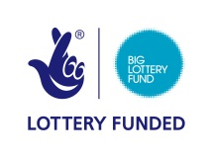
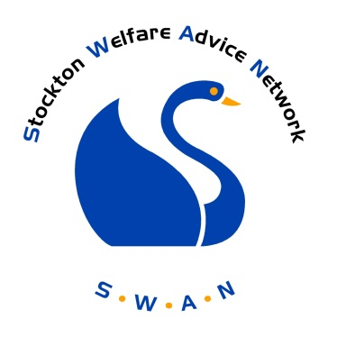

Stockton Welfare Advice Network
Membership Requirements and Benefits
ASSOCIATE MEMBERSHIP

Background

The SWAN was initiated on 1st October 2013 by nine organisations with experience of advice provision and an expertise of the issues and problems faced by the residents of Stockton Borough.

The project is funded through the Advice Service Transition Fund, administered through the Big Lottery Fund.

The overall aim of the project is to enable residents to easily and quickly access the right advice at the right time. This will be achieved by:

- The establishment of a Network, a group of advice agencies coming together through meetings and electronic communication through the SWAN website to share information and resources.

- The establishment of an agreed system of recording data across different advice agencies that will enable advice needs to be consistently assessed, unmet need evidenced, maximise the most effective use of resources and target resources at prevention and early intervention stage

- The creation of a portal website that will give people a single access point to get the right information they need to resolve their problem at the earliest opportunity

- The creation of an online referral system allowing clients to be accurately and easily transferred from one agency to another

- Provision of training on how to access and use the portal

The SWAN Website

The SWAN website will have two separate sites: one for the public and another for full members of the network.

Site 1: public access

The front facing site will contain a directory of local advice and information services. Search functions will allow the public, agencies and statutory departments to look for the most appropriate service for them or their clients whether by subject of level of help needed.

There will be links to other websites from National Organisations and self -help materials. Monitoring tools built into the site will enable us to collect valuable data on what issues are affecting Stockton Borough’s residents.

This site will also contain news and events information, giving you the opportunity to advertise relevant events led by your organisation.

Site 2 : accessible by full members only

The second site will be accessed by full members only.

The site will contain an online referral system allowing you to transfer your client’s details securely to another member. Built into the process is a mechanism allowing the agency receiving the referral to give you feedback on your client. This process, in time, will generate a better understanding of other organisations and encourage more appropriate referrals for all. Monitoring the referrals will also give invaluable information about Stockton Borough’s residents and their issues.

The second site will also contain a training and events page, enabling members to promote events to other professionals ensuring maximum attendance. The site will act as an information sharing hub where members can display examples of good practice as well as exchange information on issues which affect Stockton Boroughs residents.

Membership Schemes available

There are two types of membership. All interested agencies will be asked to complete the Associate Membership initially, followed by an invitation to apply for Full Membership.
Associate Membership: Members will have their organisation listed within the directory of advice services on the SWAN website. You will have appropriate permissions to your own page on the website, enabling you to update the information held, ensuring that you continue to get the most appropriate clients accessing your services.

Full Membership: Members will have access to the same facilities as the associate members but will have additional permission to use the online referral system. Full membership will entitle you to access information on the professional training events advertised by other members as well as access to information sharing platforms.

Why should we join?
There are many reasons why you should become a member of SWAN.
-Closer links with other advice agencies and a better awareness of services available and how to access them
This will also lead to opportunities for joint development of funding bids and service delivery.
-Access to an online referral system within the SWAN website

This allows those with Full SWAN membership to refer to other members using a common referral form. This will avoid the repetition of service delivery caused by clients returning to original agencies due to inappropriate referrals or signposting. You will be given free training and materials on the system

-Access to regular reports from data collected from all members

This will be publicised through the SWAN monthly newsletter. This will enable members to more accurately quantify need and use resources more effectively

-Social policy reporting tool

The portal will provide a central location in Stockton for reporting common issues on social welfare issues. These will be regularly monitored and reported back through the SWAN website through a monthly newsletter. Access will be available to Full Members only.

-An information sharing platform

For Full Members, there will be a platform where you can display events, training, notices or employment opportunities. There will also be a yearly review where you will be consulted about the delivery of the network

Membership will also allow your organisation access to supplementary advice from other network organisations

Requirements for associate membership

In order to benefit from associate membership, each associate member will have to agree to the following:

- agree to provide an information and / or advice service in social welfare matters
- agree to provide a service which is accessible by the residents of Stockton Borough
- sign up to the SWAN Equality and Diversity Statement
- confirm that your organisation has an Equality and Diversity policy or is working to develop and implement one;
- confirm that your organisation has a complaints procedure or is working to develop and implement one;
- confirm that your organisation has a data protection; security and confidentiality policy
- provide content for the SWAN website, including details of how the public access your service and other members of SWAN refer to you and areas of advice or support your provide.
- Agree to update any organisational changes directly onto the directory contained within the SWAN website within 2 weeks of their implementation;
- agree to share data on clients profiles and outcomes
- communicate experience of the SWAN and the benefits of working together as a network to other organisations;
- participate in Network Events and the Annual Review to share practice and improve advice giving across Stockton
- agree to adhere to policies and procedures implemented and agreed by the SWAN Project Board
- Agree to give the SWAN Project Board one month’s notice in writing if leaving the network

Please note that breaches of any requirement will be taken seriously as they affect the reliability of the whole network and the directory. Breaches will be presented to the SWAN Partnership Board who may decide that membership is cancelled which will result in the removal of your organisation from the directory.

How do we apply to join?

All applications will be considered by the SWAN Project Board.
The form should be returned to :
SWAN
Stockton and District Advice and Information Service
Bath Lane
Stockton on Tees
TS18 2DS

OR emailed to
swan@stockton-cab.co.uk

If you have any queries please contact the SWAN Project Manager, Marie Kerr on 01642 626102

What happens next?
Your application will be considered by the SWAN Project Board and you will be informed in writing.
If you application is successful, you will then be invited to apply for full membership.

