Emergency Food Aid Information Directory
July 2017
Stockton & District Advice & Information Service

Emergency Food Aid Information Directory – 2017

This Directory gives details of organisations that can provide emergency food assistance to people in Stockton Borough. The Directory is based on information supplied by organisations and indicates the type of assistance available, where and when the assistance is available and if any referral is required to access the service.

Stockton & District Advice & Information Service (SDAIS) has collected and circulated this information as part of its work with a wide range of organisations to support people who are in crises.

SDAIS would like to thank all those organisations who have provided their information and to Crisis Support Steering Group, who helped to develop this Directory.

If any information changes, we would be pleased to hear from individuals and agencies so that the Directory can be updated.

Stacey Sowerby
Help Through Crisis Co-ordinator

Stockton & District Advice & Information Service
Bath Lane
Stockton-on-Tees
TS18 2DS

Tel: 01642 535471

Email: ssowerby@stockton-cab.co.uk

 | Organisation | Address | Opening Times | Food/Provisions Provided | Quantity Allowed | Referral needed? | Contact
Monday | The Salvation Army | Palmerston Street, Stockton-on-Tees, TS18 1NU | Monday – Friday  9am-12pm (Term time)  9.30-11am, closed Thursdays during school holidays | - Food parcels  - Toiletries  - Clothing  - Bedding  - Sleeping bags | 3 in first month, then 1 per month | Referral letter from advice agencies such as CAB, Stockton Council, Bridges, New Walk, Turnaround homes, Lifeline, Five lamps and Thirteen | John Preston  01642 617 629
 | A Way Out | The Gate,  1-2 Castlegate Quay,  The Riverside,  Stockton on Tees.  TS18 1BZ | Mondays  1pm-3pm | - Food Parcels  - Toiletries  - Hot drinks  - Snacks | One parcel per week | Referral not needed, women must be over 18  Any men are signposted to Salvation Army or Moses Project | Rachel Johnson  01642 655071
 | Labyrinth | The Town House  2 Skinner Street  Stockton on tees  TS18 1DY | Monday to Saturday  9am-4.30pm | -Food parcels  - Hot meals  -Help bank (pots, pans etc) |  | Referral needed  Complete Labyrinth referral card | Debbie  01642 973771
 | Organisation | Address | Opening Times | Food/Provisions Provided | Quantity Allowed | Referral needed? | Contact
Tuesday | The Salvation Army | Palmerston Street, Stockton-on-Tees, TS18 1NU | Monday – Friday  9am-12pm (Term time)  9.30-11am, closed Thursdays during school holidays | - Food parcels  - Toiletries  - Clothing  - Bedding  - Sleeping bags | 3 in first month, then 1 per month | Referral letter from advice agencies such as CAB, Stockton Council, Bridges, New Walk, Turnaround homes, Lifeline, Five lamps and Thirteen | John Preston  01642 617 629
 | Trussell Trust | 4-6 West Precinct, Billingham Town Centre, TS23 2NH | Tuesdays and Thursdays 11am – 2pm | - Food parcels  - Toiletries  - Clothing  - Pet food  - Hot water bottles (when donated) | 3 parcels initially during period of crises, but can continue support if a professional is working with client to relieve crises. | Food voucher/referral from doctors, schools or advice agencies such as CAB, A Way Out, Thirteen | Jill or Alan Coyle  07583 575 522
 | The Moses Project | Rivers of Life Church,  Lightfoot Grove, Stockton-on-Tees, TS18 3EE | Tuesday-Friday 10am-3pm | - Hot homemade meals  - Snacks  - Hot drinks  - Help with forms | No limit | No referral needed, although clients must be male, over 25 with addiction issues | Brian Jones  07753 301 012
 | Labyrinth | The Town House  2 Skinner Street  Stockton on tees  TS18 1DY | Monday to Saturday  9am-4.30pm | -Food parcels  - Hot meals  -Help bank (pots, pans etc) |  | Referral needed  Complete Labyrinth referral card | Debbie  01642 973771
 | Organisation | Address | Opening Times | Food/Provisions Provided | Quantity Allowed | Referral needed? | Contact
Wednesday | The Salvation Army | Palmerston Street, Stockton-on-Tees, TS18 1NU | Monday – Friday  9am-12pm (Term time)  9.30-11am, closed Thursdays during school holidays | - Food parcels  - Toiletries  - Clothing  - Bedding  - Sleeping bags | 3 in first month, then 1 per month | Referral letter from advice agencies such as CAB, Stockton Council, Bridges, New Walk, Turnaround homes | John Preston  01642 617 629
 | Trussell Trust | Hebron Church  Britannia Road  (corner of Bishopton Road & Vicarage Street)  Stockton-on-Tees  TS19 0AJ | Wednesdays and Fridays 10am-1pm | - Food parcels  - Toiletries  - Pet food (when donated)  - Hot drinks  - Snacks | 3 parcels during period of crises, continued support if a professional is working with client to relieve crises. | Food voucher/referral from doctors, schools or advice agencies such as CAB, A Way Out, Thirteen | Andrea Edwards  07845 689 012
 | Destiny Café | Destiny Church  395 Norton Road  Norton  Stockton-on-Tees  TS20 2QQ | Wednesdays 10am-2pm | - Hot meals  - Hot drinks  - Food parcels (Only when left over items are available, Destiny is not a foodbank) | Unlimited with voucher from CAB | Voucher signed and checked by Minister, distributed by CAB | Cath Harris  01642 559 797
 | Parish Church | Stockton Parish Church  High Street Stockton  Stockton-on-Tees  TS18 1SP | Wednesdays 1pm-2pm | - Soup and bread | 1 per visit | Anyone is welcome | 01642 611 734
 | The Moses Project | Rivers of Life Church, Lightfoot Grove, Stockton-on-Tees, TS18 3EE | Tuesday-Friday 10am-3pm | - Hot homemade meals  - Snacks  - Hot drinks  - Help with forms | No limit | No referral needed, although clients must be male, over 25 with addiction issues | Brian Jones  07753 301 012
 | Labyrinth | The Town House  2 Skinner Street  Stockton on tees  TS18 1DY | Monday to Saturday  9am-4.30pm | -Food parcels  - Hot meals  -Help bank (pots, pans etc) | Referral needed  Complete Labyrinth referral card |  | Debbie  01642 973771
 | Organisation | Address | Opening Times | Food/Provisions Provided | Quantity Allowed | Referral needed? | Contact
Thursday | The Salvation Army | Palmerston Street, Stockton-on-Tees, TS18 1NU | Monday – Friday  9am-12pm (Term time)  9.30-11am, closed Thursdays during school holidays | - Food parcels  - Toiletries  - Clothing  - Bedding  - Sleeping bags | 3 in first month, then 1 per month | Referral letter from advice agencies such as CAB, Stockton Council, Bridges, New Walk, Turnaround homes, Lifeline, Five lamps and Thirteen | John Preston  01642 617 629
 | Trussell Trust | 4-6 West Precinct, Billingham Town Centre, TS23 2NH | Tuesdays and Thursdays 11am – 2pm | - Food parcels  - Toiletries  - Clothing  - Pet food  - Hot water bottles (when donated) | 3 parcels initially during period of crises, but can continue support if a professional is working with client to relieve crises. | Food voucher/referral from doctors, schools or advice agencies such as CAB, A Way Out, Thirteen | Jill or Alan Coyle  07583 575 522
 | The Moses Project | Rivers of Life Church, Lightfoot Grove, Stockton-on-Tees, TS18 3EE | Tuesday-Friday 10am-3pm | - Hot homemade meals  - Snacks  - Hot drinks  - Help with forms | No limit | No referral needed, although clients must be male, over 25 with addiction issues | Brian Jones  07753 301 012
 | Thornaby Foodbank | Thornaby Baptist Church,  Thorntree Road,  (Next to Mandale Mill primary school) | Thursdays 12pm-2pm | - Food parcels  - Hot drinks  - Toiletries  - Clothing (When donated)  - Weekly quiz with prizes | 4 weeks’ worth, then new referral needed. 12 parcels in total. After this the foodbank need to know that client’s issues are being addressed. | No referral for first visit. Foodbank refers visitors to CAB or other appropriate charity to ensure they have food vouchers for future visits and that their issues are being dealt with. | Christine Shearer  0771 931 2341
 | Labyrinth | The Town House  2 Skinner Street  Stockton on tees  TS18 1DY | Monday to Saturday  9am-4.30pm | -Food parcels  - Hot meals  -Help bank (pots, pans etc) | Referral needed  Complete Labyrinth referral card |  | Debbie  01642 973771

 | Organisation | Address | Opening Times | Food/Provisions Provided | Quantity Allowed | Referral needed? | Contact
Friday | The Salvation Army | Palmerston Street, Stockton-on-Tees, TS18 1NU | Monday – Friday  9am-12pm (Term time)  9.30-11am, closed Thursdays during school holidays | - Food parcels  - Toiletries  - Clothing  - Bedding  - Sleeping bags | 3 in first month, then 1 per month | Referral letter from advice agencies such as CAB, Stockton Council, Bridges, New Walk, Turnaround homes, Lifeline, Five lamps and Thirteen | John Preston  01642 617 629
 | Trussell Trust | Hebron Church  Britannia Road  (corner of Bishopton Road & Vicarage Street)  Stockton-on-Tees  TS19 0AJ | Wednesdays and Fridays 10am-1pm | - Food parcels  - Toiletries  - Pet food (when donated)  - Hot drinks  - Snacks | 3 parcels initially during period of crises, but can continue support if a professional is working with client to relieve crises. | Food voucher/referral from doctors, schools or advice agencies such as CAB, A Way Out, Thirteen | Andrea Edwards  07845 689 012
 | The Moses Project | Rivers of Life Church, Lightfoot Grove, Stockton-on-Tees  TS18 3EE | Tuesday-Friday 10am-3pm | - Hot homemade meals  - Snacks  - Hot drinks  - Help with forms | No limit | No referral needed, although clients must be male, over 25 with addiction issues | Brian Jones  07753 301 012
 | Words of Welcome | Words of Welcome Drop in café  St Cuthbert’s Church  Yarm Road  TS18 3NR | Friday  11am-1.30pm | - Hot food (soup, toasties)  - Sandwiches  - Cakes  - Biscuits  - Hot drinks | No limit | Anyone is welcome | Father Cooper  01642 674 321
 | Labyrinth | The Town House  2 Skinner Street  Stockton on tees  TS18 1DY | Monday to Saturday  9am-4.30pm | -Food parcels  - Hot meals  -Help bank (pots, pans etc) | Referral needed  Complete Labyrinth referral card |  | Debbie  01642 973771
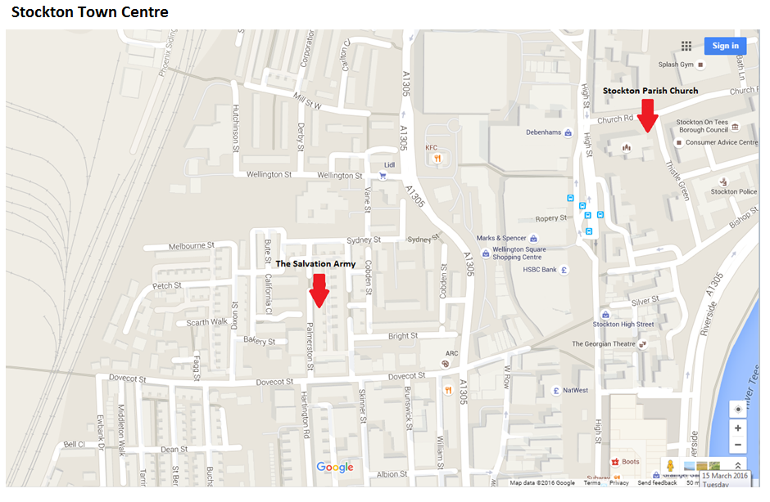
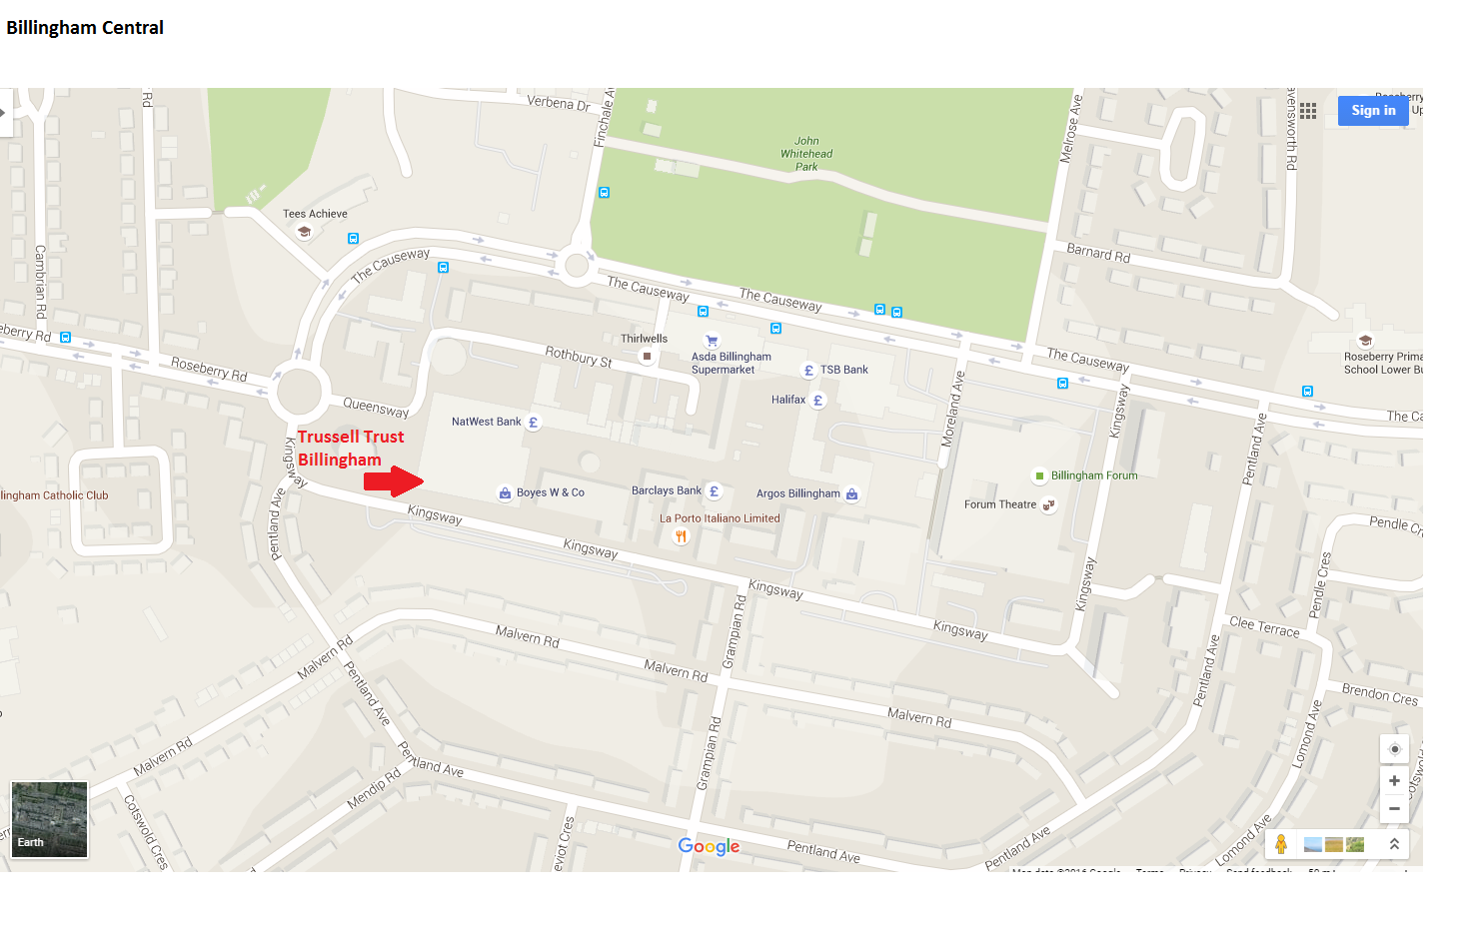
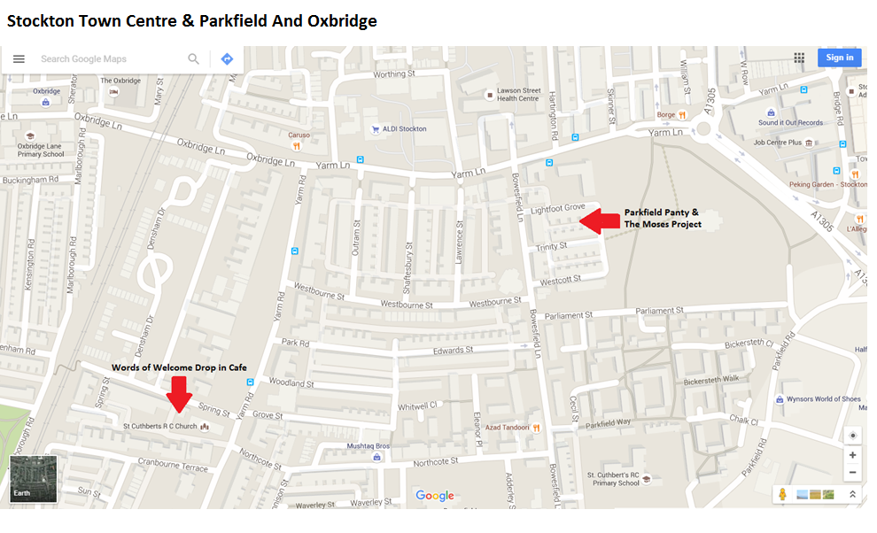

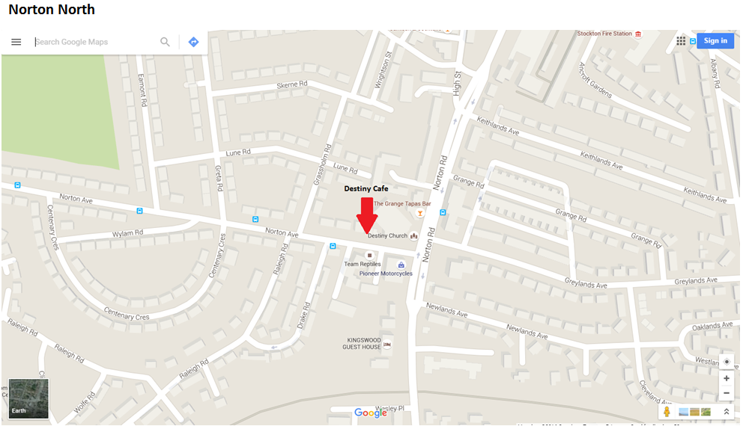

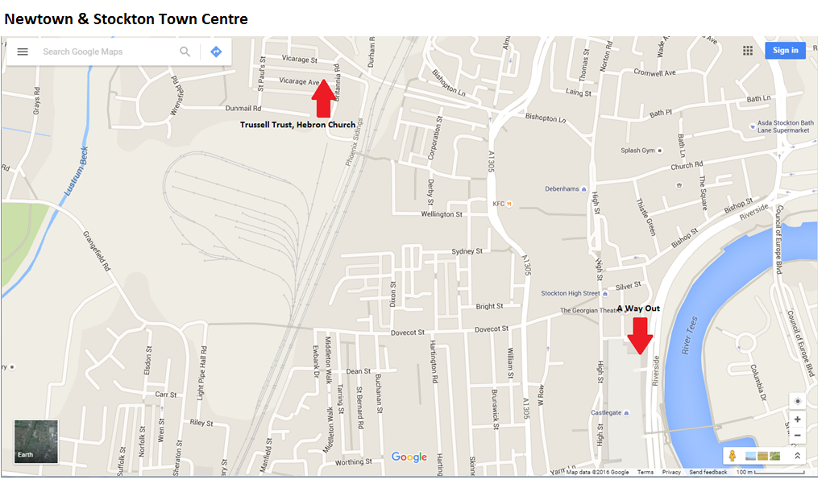

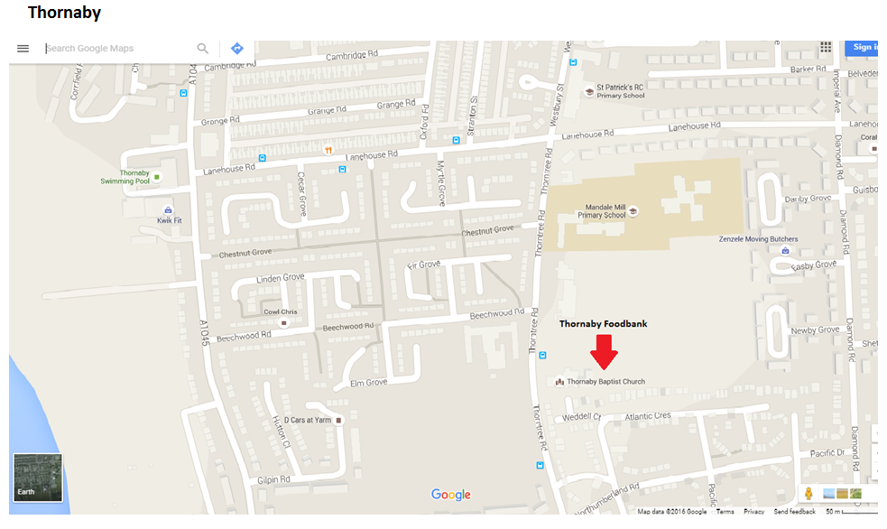

Labyrinth Café
